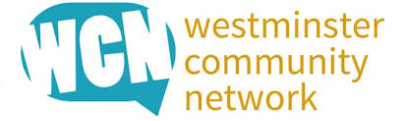
Manifesto for a strong, sustainable and vibrant Civic Community in Westminster
Who we are
The WCN is an independent network of local charities and community organisations working in Westminster.
It works to build relationships, share ideas and influence strategic decision making across the city (and bi/ triborough where relevant) for the benefit of the diverse communities that make up the City of Westminster and the voluntary sector.
The WCN is crucial to the co-design and development of a vibrant civic community sector in Westminster for the future. It plays a pivotal role in communicating with the statutory sector and commissioners of services delivered by the voluntary and community sector in the borough.
OUR MISSION
- To be the recognised and respected voice of the voluntary and community sector in Westminster.
- To be the go-to point of reference for those wishing to understand and service the diverse communities that make up the City.
- To provide statutory partners and others with clear, evidence-based information to inform their strategic decision making.
- To represent the sector at key groups and committees and to ensure quality feedback to the voluntary and community sector.
- To act as a critical friend to colleagues in the statutory and private sectors
OUR VALUES
- We will be open, transparent and accountable to the organisations and communities we represent.
- We believe in strong and active partnerships, in which everyone operating in the voluntary and community sector who wants to can have a voice.
How we operate
The WCN is served by an elected Chair and Vice-Chair; and coordinated by the CVS team at One Westminster.
The WCN is committed to represent the diversity of the communities we serve in all we do.

